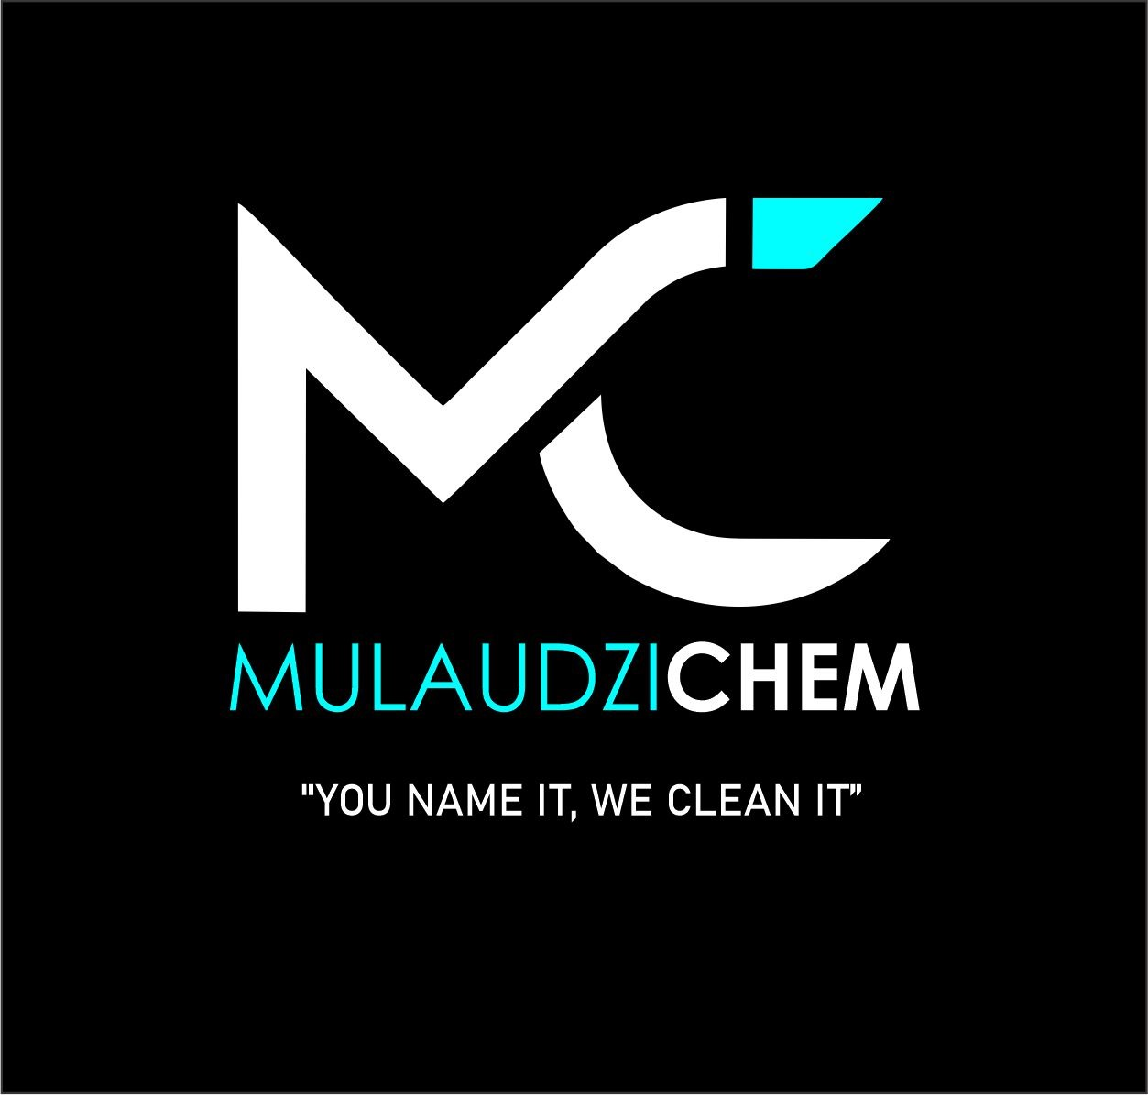
Mulaudzi Solutions Pty Ltd

Amberfield City , 0175, TEL: 0792130538 or 0732605131
Email: shanemulaudzi@gmail.com & chulufuzile@gmail.com
Banking Detail Acc #1290716941
Acc holder : Mulaudzi Solution
Bank Name : Capitec

 | CAR WASH PRODUCT | 5LITRE | 25LI
 | Silicone Tyre shine (clear ) | R250 | R850
 | Super ultra (Tyres -Hi Shine ) | R250 | R850
 | Tyre Gel | R250 | R850
 | Wash and shine shampoo | R100 | R270
 | Hi foam shampoo | R100 | R270
 | Auto Foam Car Shampoo | R120 | R350
 | Heavy duty (all purpose ) | R120 | R300
 | Engine cleaner (Degreaser) | R120 | R300
 | Solvent engine Degreaser(one shot) | R260 | R700
 | Magwheel cleaner | R150 | R350
 | Aluminium cleaner | R150 | R350
 | Upholstery cleaner | R 120 | R300
 | Leather cream | R250 | R800
 | Silicone tyre &Dash with no perfume | R250 | R1250
 | Silicone dash with perfume | R300 | R1300
 | Thick dash | R250 | R1200
 | Dash spray 400ml | R90
 | Window &wash bay acid | R150 | R550
 | Methylated Spirit | R300 | R1200
 | Window cleaner | R150 | R400
 | Car Polish | R250 | R1100
 | Bale cloth 5kg | R150
 | Chamois absorbers | R70
 | Sponges
 | Small | R10
 | Big | R15
 | Window squeeze | R60
 | Microfibre cloth | R40
 | Spray Bottle | R60
 | Leather Cleaning fluid | R150 | R400
 | Scrubbing Brush
 | small | R35
 | Big | R65
 | Driveway &Paving cleaner | R150 | R400
 | Pineapple flavoured perfume
 | 500ml | R300
All 25l container are on exchange basis. if not, R50 replacement fee will be charged

Sales contact:

Shane :0792130538

Chulu :0732605131

